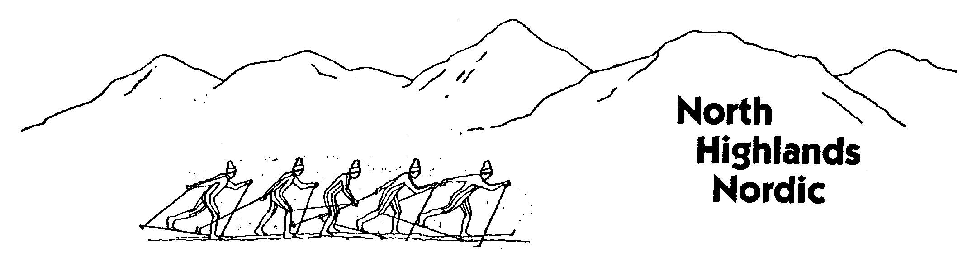
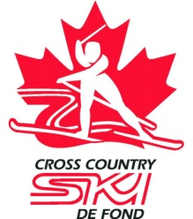
www.nhn.xcski.ca
nhn@xcski.ca
902-383-2479

North Highlands Nordic
Welcomes you to the

NOVA SCOTIA PROVINCIAL
CROSS COUNTRY SKI CHAMPIONSHIPS
March 3rd& 4th, 2018

CAPE NORTH, NOVA SCOTIA

Dear Coaches and Competitors:

On behalf of North Highlands Nordic and Cross Country Nova Scotia, we would like to invite you to participate in the Nova Scotia Provincial Cross Country Ski Championships, on our trails in Cape North. Please find enclosed the race information package for this event. All levels of skiers are encouraged to participate.

This will be a two day event, with the classic race on the Saturday and the free technique race on the Sunday. The medals for Saturday will be given out at the meal after Saturday's race in the same facility.

You are required to register by Midnight, Thursday, March 1st. For more information please read the following race notice. We hope you can join us.

This year, the provincial championships will be held in conjunction with the North Highlands Nordic Loppet, which will be held on Sunday.

Sincerely,
Linda Murray
Chief of Race

RACE INFORMATION PACKAGE

Host Club: North Highlands Nordic Cross Country Ski Club

Sanctioned by: Cross Country Ski Nova Scotia

Location: Cape North, Cape Breton

Eligibility Any skier, all ages

Registration
Fees per Race* | Juvenile & Older | Midget & Younger
CCC Club Members | $30 | $15
NHN Season Pass Holders | $20 | $10
Independent Participants** | $35 | $20
**Non-members of a CCNS club or CCC club. This fee includes a day license of $5.00 with Cross Country Nova Scotia. Independent racers must also complete a waiver before racing.

Note: Each race fee includes trail fee for the specific day and a chance at draw prizes. It does not include the cost of a meal.
- Meals options can be selected on the registration form and the cost will be added for payment.
- Saturday’s meal cost for is $10, $5 for 12 & under (Pay with cash in ski room only)
- Coaches and volunteers can ski for free on Saturday & Sunday.

Registration & Payment

- Registration must be completed by one of the two options
  - Complete registration forms & pay fees in person at North Highlands Nordic
  - On Line at: Zone4.ca

Registration Closing: midnight Thursday, March 1, 2017

Waxing Facility: North Highlands Nordic Wax/Warm-Up Room

Accommodations: Go to www.nhn.xcski.ca for accommodation links, or call 383-2479.

Cancellation Policy:

The North Highlands Nordic race committee reserves the right to cancel or postpone the 2018 Nova Scotia Provincial Championships due to unfavourable race conditions. Notice will be given to Cross Country Ski Nova Scotia by noon Wednesday, February 28th, 2018. This information will be posted on the CCSNS website: www.crosscountryns.ca and the North Highlands website: http://nhn.xcski.ca/

Race Distances
Category | Year of Birth | Age on Dec. 31 2018 | Saturday: Classic  Individual Start |  | Sunday: Free Technique  Mass Start
 |  |  | Male | Female | Male | Female
Grand Master | 1968 & Earlier | 50 + | 10 km | 10 km | 10 km | 10 km
Master | 1969 - 1988 | 30 – 49 | 10 km | 10 km | 20 km | 15 km
Open | 1989 - 1999 | 19 - 29 | 10 km | 10 km | 15 km | 10 km
Junior | 2000 - 2001 | 17 – 18 | 7.5 km | 7.5 km | 10 km | 10 km
Juvenile | 2002 - 2003 | 15 - 16 | 7.5 km | 7.5 km | 7.5 km | 7.5 km
Midget | 2004 - 2005 | 13 – 14 | 5 km | 5 km | 5 km | 5 km
Pee Wee | 2006 - 2008 | 10 – 12 | 2.5 km | 2.5 km | 2.5 km | 2.5 km
Atoms | 2009 - 2011 | 7 - 9 | 1 km | 1 km | 1 km | 1 km

Event Schedule

Saturday

10:00 – 12:30 pm Official Training& Bib Pickup

12:30 pm Pre-Race Meeting (for coaches, new racers & young racers)

1:00 pm Individual Start Classic Races

6:00 pm Post Race Meal

6:30 pm Awards

Sunday

8:00 – 9:30 am Official Training& Bib Pickup

10:30 am Pre-Race Meeting (for coaches, new racers & young racers)

11:00 am Mass Start Skate Races

12:00 pm Post Race BBQ

12:30 Awards

