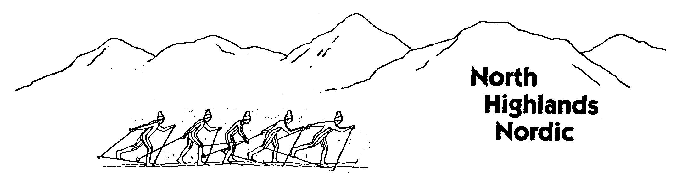
North Highlands Nordic Annual Loppet, March 12, 2017
Registration Form
Name_________________________________________________
Hometown_______________________________ Bib #_________
E-mail_____________________________________
Phone Number_____________________________
Date of Birth: Day_______ Month_______ Year_______
Ski Club_______________________________________________
Male_______ Female_______
Distance:
21km______ 10.5km______ 5km______ Cookie______

Amount Paid: $___________________________
Event Waiver and Release
I hereby agree to abide by the rules of Cross Country Canada (CCC) and Cross Country Ski Nova Scotia (CCSNS) to participate in the 2017 North Highlands Nordic Loppet sanctioned by CCSNS in accordance with the Association’s Rules and By-Laws.
In consideration of Cross Country Canada, Cross Country Nova Scotia, and the North Highlands Nordic Ski Club’s acceptance of my participation in the 2017 North Highlands Nordic Loppet, I hereby, for myself, my heirs, executors, administrators and assigns, forever release, discharge, and hold harmless Cross Country Canada, Cross Country Ski Nova Scotia, and North Highlands Nordic Ski Club, it’s directors, officers, employees, volunteers, representatives or agents.
Signature____________________ Date______________
Participants under the age of 19 years must have the following signed by a parent:
As the parent or guardian of the above named entrant, under the age of 19, I have read and understood the above Waiver and Release and accept its terms and conditions on the entrant’s behalf.
Signature____________________ Date______________

